HTML

1. What is HTML? Give basic structure of the HTML page.

* HTML stands for Hyper Text Markup Language
* HTML is the standard markup language for creating Web pages
* HTML describes the structure of a Web page
* HTML consists of a series of elements
* HTML elements tell the browser how to display the content
* HTML elements label pieces of content such as "this is a heading", "this is a paragraph", "this is a link", etc.

Structure of html.

<!DOCTYPE html>  
<html>  
<head>  
<title>Page Title</title>  
</head>  
<body>  
  
<h1>My First Heading</h1>  
<p>My first paragraph.</p>  
  
</body>  
</html>

* The <!DOCTYPE html> declaration defines that this document is an HTML5 document
* The <html> element is the root element of an HTML page
* The <head> element contains meta information about the HTML page
* The <title> element specifies a title for the HTML page (which is shown in the browser's title bar or in the page's tab)
* The <body> element defines the document's body, and is a container for all the visible contents, such as headings, paragraphs, images, hyperlinks, tables, lists, etc.
* The <h1> element defines a large heading
* The <p> element defines a paragraph

2. Difference between inline and block level element.

|  |  |
| --- | --- |
| **Block** | **Inline-block** |
| A block element begins on a new line. | It remains inline with all the text around the element and appears the same as inline. |
| Examples: div, p, li, main, etc. | It has no tag examples as it can be applied to any tag using CSS. |
| CSS property: display:block | CSS property: display:inline-block |

CSS

1. Explain the different ways in which CSS can be applied to HTML, what is the preferred way and why.

CSS can be added to HTML documents in 3 ways:

* **Inline** - by using the style attribute inside HTML elements
* **Internal** - by using a <style> element in the <head> section
* **External** - by using a <link> element to link to an external CSS file

The most preffered way to add CSS, is to keep the styles in external CSS files because, it has a better separation of concerns, is the easiest to debug, and allows us to cache the file to improve load times.

2. What are different CSS selectors, with example explain Element, Class and Id selectors.

We can divide CSS selectors into five categories:

* Simple selectors (select elements based on name, id, class)
* [Combinator selectors](https://www.w3schools.com/css/css_combinators.asp) (select elements based on a specific relationship between them)
* [Pseudo-class selectors](https://www.w3schools.com/css/css_pseudo_classes.asp) (select elements based on a certain state)
* [Pseudo-elements selectors](https://www.w3schools.com/css/css_pseudo_elements.asp) (select and style a part of an element)
* [Attribute selectors](https://www.w3schools.com/css/css_attribute_selectors.asp) (select elements based on an attribute or attribute value)

|  |  |  |
| --- | --- | --- |
| **Selector** | **Example** | **Example description** |
| [#*id*](https://www.w3schools.com/cssref/sel_id.asp) | #firstname | Selects the element with id="firstname" |
| [.*class*](https://www.w3schools.com/cssref/sel_class.asp) | .intro | Selects all elements with class="intro" |
| [*element.class*](https://www.w3schools.com/cssref/sel_element_class.asp) | p.intro | Selects only <p> elements with class="intro" |
| [*](https://www.w3schools.com/cssref/sel_all.asp) | * | Selects all elements |
| [*element*](https://www.w3schools.com/cssref/sel_element.asp) | p | Selects all <p> elements |
| [*element,element,..*](https://www.w3schools.com/cssref/sel_element_comma.asp) | div, p | Selects all <div> elements and all <p> elements |

3. With the help of a diagram explain CSS Box Model.

The CSS Box Model

In CSS, the term "box model" is used when talking about design and layout.

The CSS box model is essentially a box that wraps around every HTML element. It consists of: margins, borders, padding, and the actual content. The image below illustrates the box model:

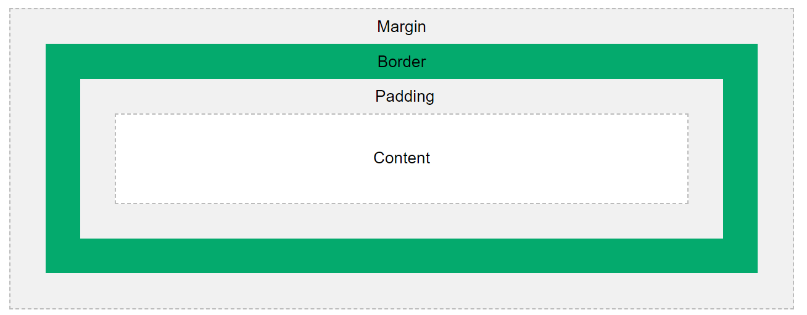

Explanation of the different parts:

* **Content** - The content of the box, where text and images appear
* **Padding** - Clears an area around the content. The padding is transparent
* **Border** - A border that goes around the padding and content
* **Margin** - Clears an area outside the border. The margin is transparent

The box model allows us to add a border around elements, and to define space between elements.

JavaScript

1. List down ways in which JavaScript command can be added to a webpage, what is the preferred way.

1. Embedding code
2. Inline code
3. External file

### **I. Embedding code:-**

To add the JavaScript code into the HTML pages, we can use the <script>.....</script> tag of the HTML that wrap around JavaScript code inside the HTML program. Users can also define JavaScript code in the [<body> tag](https://www.javatpoint.com/html-body-tag) (or we can say body section) or [<head> tag](https://www.javatpoint.com/html-head) because it completely depends on the structure of the web page that the users use.

### **II. Inline code:-**

Generally, this method is used when we have to call a function in the HTML event attributes. There are many cases (or events) in which we have to add JavaScript code directly eg., OnMover event, [OnClick](https://www.javatpoint.com/html-button-onclick), etc.

### **III. External file:-**

We can also create a separate file to hold the code of JavaScript with the (.js) extension and later incorporate/include it into our HTML document using the **src** attribute of the <script> tag. It becomes very helpful if we want to use the same code in multiple HTML documents. It also saves us from the task of writing the same code over and over again and makes it easier to maintain web pages.